I Feel Sick

If I feel sick, I need to stay home. My mom or dad should call my doctor. I will need to tell my parents and doctor how I feel, such as I have a fever, a cough, or my stomach hurts. My doctor or nurse will tell me what I need to do.
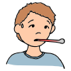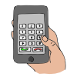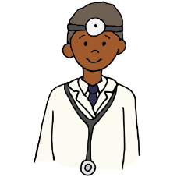
I should not go to the doctor’s office unless my doctor tells me to go. There are a lot of people who need to see the doctor right now because of the Coronavirus. People need to be careful not to spread germs, so it is best if I stay home when I am sick.
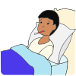
If I am sick, it is helpful for me to wear a mask, if I have one, so I don’t give my germs to other people. I will remember to cough or sneeze into my elbow. I will throw away my tissues in the trash can. I will be sure to wash my hands often for 20 seconds with soap and water.
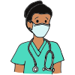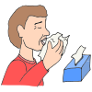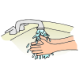
If I start to feel really bad and have trouble breathing, I should tell someone right away. I may need to go to the hospital emergency room immediately.

